NOTEPAD – Output Reports to Microsoft Notepad

When printing a report and selectin the output to screen, the report will display in a text file or directly to Microsoft notepad so that a full screen is displayed. The N-K-1 Notepad parameter dictates the functionality of reports sent to output directly to Microsoft NotePad. This provides search capabilities and provided for more dynamic scrolling. To print from notepad requires selecting a font so the report is printed correctly. For printing, the best option is to return to the Advantzware print selecting and select the output to printer. The logical value = NO will turn this feature off and output all reports to a text file. Se the logical value = YES and reports will output to Notepad. Set the Character Value = spaces and all users will output reports to Notepad. Set the Character Value = Notepad and the users defined in the user group called Notepad will be the only users that will display reports to Notepad. The User Group must be created under the network administration, change user groups menu (N-C).

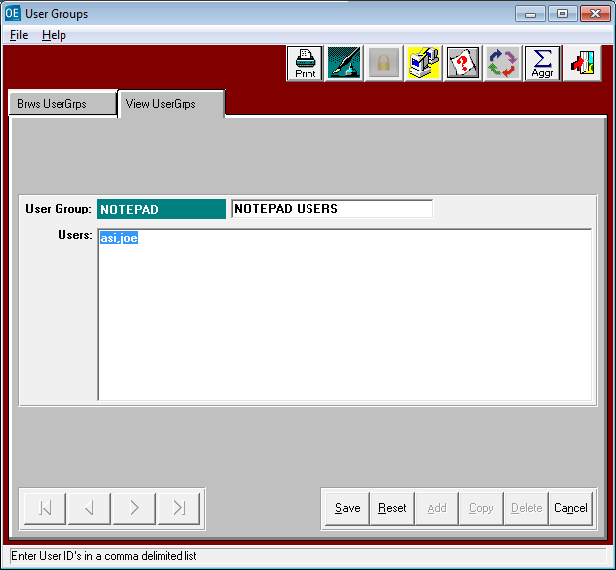

SYSTEM ADMINISTRATION – CHANGE USER GROUPS.

To set the notepad by user ID, a new user group must be created. This must be called NOTEPAD. The User Group must be created under the network administration, change user groups menu (N-C). Each user ID that desires to display reports in Notepad must be listed as a user. The User Id must match the name defined under system administration’s users file.

